|  |  |
| --- | --- |
| S | 17 |
| N |  |



**De La Salle University • College of Computer Studies**

Introduction to Artificial Intelligence (INTESYS)

AY 2014-2015 Term 1

**Expert System for Medical Diagnosis**

Name (last name first) : Aquino, Kurt Neil

Esquillo, Lance Patrick

Tapales, Carlo Gabriel

Section : S17

E-mail address : kurt_aquino@dlsu.edu.ph

Date of Submission : August 20, 2014

Time of Submission :

We hereby certify that we wrote our entire knowledge base

and report without help from anyone outside our group.

________________________

Aquino, Kurt Neil

________________________

Esquillo, Lance Patrick

________________________

Tapales, Carlo Gabriel

Table of Contents:

1. Introduction page 2
2. Sample Consultations page 3 - 5
3. Knowledge Base page 5
4. Evaluation and Analysis page 6
5. Summary and Lessons Learned page 6
6. Appendix
7. Methodology page 7
8. Minutes page 7 - 10
9. The Expert System Shell page 10 - 12
10. The Knowledge Base page 12 - 14
11. Contribution of Members page 15
12. References page 16

**Introduction**

Pregnancy related diseases, or specifically, problems that occur during pregnancy are defined as complications that occur when the mother or soon-to-be mother gets sick from their workload, environment and sometimes even genetics in between the time frame of the 1st month of pregnancy, to the last month. These so-called sicknesses or rather diseases can range from treatable to mortal, and even possibly fatal, depending on the gravity or extent of the sickness. Most of these diseases should be taken care of by a certified professional.

Our group’s task was to create an expert system that can diagnose what disease the user of the system or in general terms the patient has incurred and describe to them what they specifically have, why they have it, and how to possibly treat it. Since a significant number of these diseases are serious, it is highly advised for the patient to consult with a doctor immediately. Treatment at home will not be doable as it

The expert system our group will develop requires knowledge from an expert in the field in pregnancy related problems specifically an Obstetrician / Gynecologist or OB/GYN for short. The role of these OB/GYN’s is to help facilitate their patients for a healthy pregnancy and for their patients to have healthy newborn children. OB/GYN’s first require a degree from a four-year pre-medical course (courses such as BS-Biology, BS-Psychology, BS-Chemistry, etc.) After that, they are required to go to medical school where most apply for becoming general physicians, which then take OB/GYN electives alongside their regular classes. Medical school requires at least two to four years. After that, they have to undergo medical residency. Medical residency is similar to an internship but with pay and usually takes three all the way to seven years until they are almost ready to practice OB / Gynecology. Lastly, they are required to take and pass the licensure exam for practicing OB / Gynecology. Then will all of those steps completed; they are certified OB/GYNS and can regularly practice it. It is of utmost importance that our group will interview and gather knowledge from this expert because the expert we will interview has dedicated her life to understand and practice OB / Gynecology. With the conversion of knowledge into data the expert system would understand, it would sufficient enough for the system to properly diagnose a disease if contracted by the patient.

The target audience of this expert system that our group will develop would be the poor communities in the Philippines. Most Filipino pregnant women especially in the poor community suffer from these diseases and don’t even know what they have, why they have had it for a long time, or the reasons why they have it. Another key point is that consultations with doctors are not cheap. If they have conjured a sickness, they might not have the resources to even consult a doctor before it is too late. Another important point is that there are some doctors that provide free treatment but are not accessible to some communities given some circumstances. The reason as to why our group will develop this expert system for the poor community without charge (if provided properly to the poor communities) to diagnose a patient if they incurred a disease, provide proper knowledge of the disease such as outcomes and reasons, and immediate actions to cure the disease.

**Sample Consultations**

**Subsection 1: Diagnosis of Hypertension of Preeclampsia**

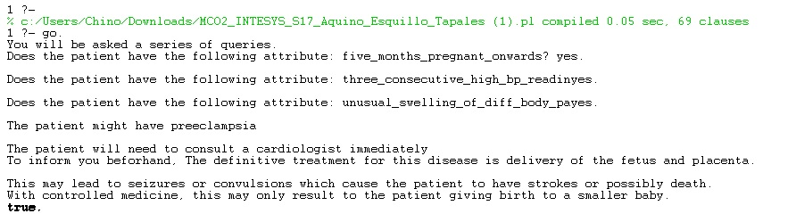

In this subsection, the expert system has taken into consideration the diseases that mostly occur after the 5th month of pregnancy and further narrowed down its possible conclusions. This subsection shows the breaking down from the general to specific statements to properly diagnose the patient by checking for defining symptoms that mostly to occur only to their respective diseases. In this case, consecutive high blood pressure readings and unusual swelling of different body parts are the main reasons the patient is diagnosed of having preeclampsia.

Subsection 2: Diagnosis of Miscarriage

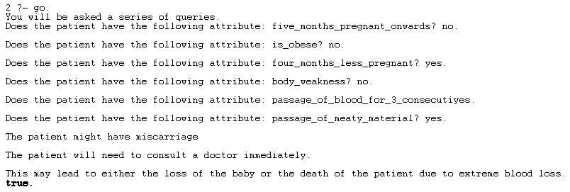

In this subsection, the expert system asked the patient some simple and some rather direct questions. Albeit the lack of common sense of the expert system, it managed to diagnose the patient in six steps. Similar to the subsection above, the system managed to break down general to specific symptoms but also worked with some ‘no’s given by the patient. The system was easily able to identify the disease in the end by ignoring the ‘no’s and prioritize the ‘yes’ or confirmed symptoms provided by the patient.

**Subsection 3: Diagnosis of Bacterial Vaginosis**

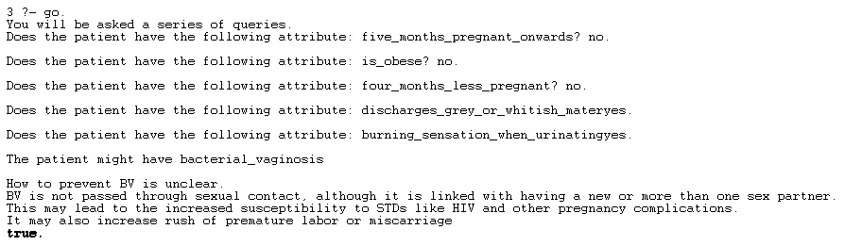

In this subsection, the beginning shows that the patient is unclear as to what month she is pregnant in but the expert system takes into consideration about diseases that can occur during the 1st month to the 9th month of pregnancy. If the patient is unsure, then it would ask more questions or more defining symptoms to figure out what disease the patient could possibly have and give a successful diagnosis with proper information.

**Subsection 4: Unknown Disease occurred**

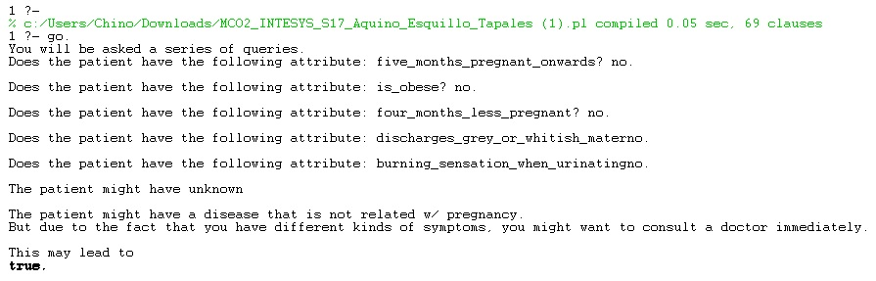

As with consultations with a human expert, the patient should at least be aware that something is wrong with herself for the very reason that the patient is looking for a diagnosis rather than a checkup. Our system is a diagnosis system for pregnant women, so other factors like non-pregnant women, males, or regular diseases are not covered here and will not be diagnosed. With that being said, the system will still recommend the patient to consult a doctor given that he/she has acknowledged at least some of the symptoms mentioned in the system.

**Subsection 5: Diagnosis of Gastroenteritis**

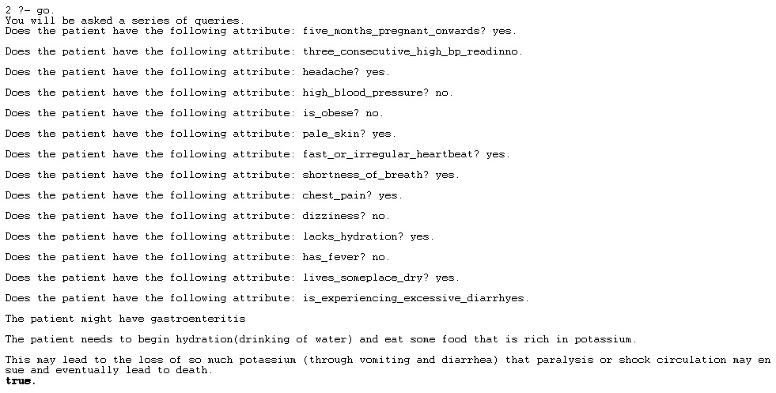

In this subsection, the expert system broke down the symptoms even further so that the patient may easily understand the questions being asked. The system then later on compiles the symptoms the patient has and then derives a conclusion, or in this case, a diagnosis. This shows that this expert system takes into consideration the patients’ uncertainty of their symptoms as well as to how to further elaborate them.

**Knowledge Base**

The most difficult part in implementing the AOG is finding a way to get back to the expected disease when one or more of its symptoms has been rejected by the user. Since most inference rules require all of its conditions, or arguments, to be satisfied before it can be confirmed true, our group must first implement into the system a case in which there will be definitive statements for each disease so as to arrive to it, given a certain set of accepted or accomplished statements/symptoms. Other than that, most of the other rules the system uses are fluid as some of it are applied to multiple cases or diseases.

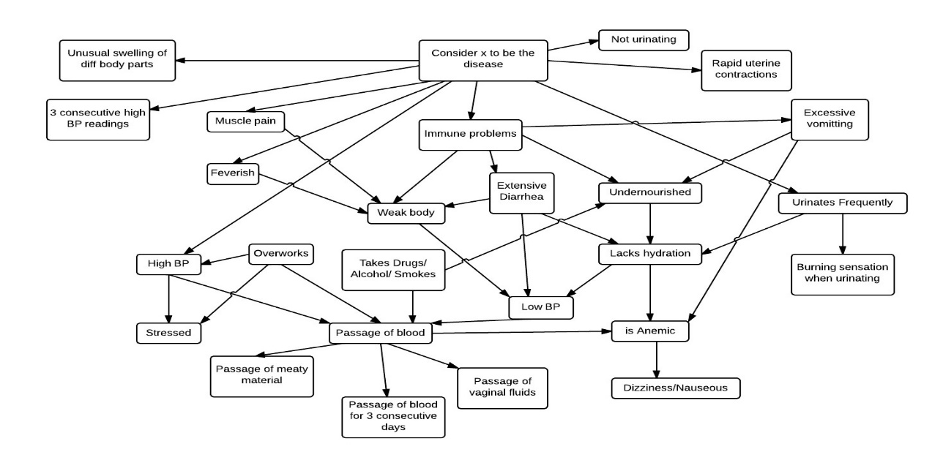

**Evaluation and Analysis**

As already presented by the simulations in the sample consultations sections of this paper, our group’s system, albeit its simplicity, accomplishes its specified task, that being the diagnosis of certain diseases possibly being contracted during pregnancy. Based on our simulations, the system does in fact produce proper diagnoses. Given a set of symptoms to be confirmed, our group has traced it back to their corresponding diseases every time.

No matter how “well”, in a sense, a system works, it all comes down to the integration of the knowledge base and the inference engine. The knowledge base our group’s system has is sound, proper, confirmed, and acquired from an expert in the field itself. With this, the system may be able to make use of consistent data when it comes to the actual diagnosis. The inference engine of our group’s system on the other hand, is, to be honest, too simple. Being a medical diagnostic system, the system should be able to properly handle various amounts of data, be it derived or input, so as to make accurate and precise diagnosis.

As shown in our group’s sample consultations, the system only accepts yes and no as data inputs. This greatly limits the system to “sure” or “absolute” answers from the users. That being said, one big weakness the system has is the inability to handle “uncertainty”. If the patient is unsure whether he has the symptom or not will not be acknowledged by the system as it only accepts yes and no. Our group has implemented definitive rules or defining symptoms for each disease so as to make up for this flaw. With the definitive statements, we also considered the possible rejections of, for example, 2 or more “non-definitive” symptoms of a disease, but still end in with the disease being properly diagnosed.

**Summary and Lessons Learned**

Our group created an expert system designed to diagnose pregnancy related problems catered to the poor communities. This expert system has gathered sufficient data from an expert, specifically an OB/GYN, in which that data is stored in our knowledge base. By accessing the knowledge base, the expert system can properly break down data, infer answers, and ask logical questions with the help of the inference engine. With that, the expert system can then work as it was intended to by using the forward chaining technique.

One thing that is very important in creating an expert system is the gathering of information. If the data gathered were insufficient, misinterpreted, or even incorrect, then the expert system would not be an expert system but rather an inefficient system. Insufficient in a way that it would suggest wrong and irrelevant answers and it would also frustrate and disappoint the user as it would produce inaccurate or incorrect results.

In our group’s case, it is very important that the data our group gathers is correct and relevant, in every case, as to not make wrong diagnoses; the patient might believe she might have this disease but it might just be a fever. Misinterpretation of data is not acceptable when it comes to medical diagnosis. Data representation and interpretation should be precise and consistent to the topic or theme of the expert system.

The inference engine created by the knowledge engineer is also very important for knowledge without proper implementation is similar to a car without an engine. I would simply not run. The inference engine is something like the core of the expert system, without it you just have several different bits of information not interacting with each other. As with our group’s system, if we have all the data gathered by the expert, but it is stagnant in the knowledge base, what good will the data do without the inference engine? It needs an inference engine to work with the knowledge to properly and efficiently diagnose diseases, working with the symptom data that is stored in the knowledge base.

With all that being said, for an expert system to be an “expert”, it will require a proper knowledge base taken from an expert and an efficient inference engine created by a knowledge engineer. If one of the two were missing, it would not be an expert system let alone a system.

**Appendix**

**Methodology**

Our group interviewed an expert specifically a doctor in the field of pregnancy, an OB/GYN named Dr. Maria Del Carmen Reyes on August 4, 2014 to gather the data required for the knowledge base of our expert system. After the interview was completed, the data was also re-organized in a way so that we can later convert them into rules that PROLOG would understand. An example of the organized data would be:

Name: Hypertension

Symptoms: headache, nape pain, swelling of feet

Timeframe: 7th month above

When the data was successfully organized, the group went further on to convert the data. After the conversion, the group proceeded in creating the knowledge base by inputting the converted data into the system. Once the “knowledge” was inputted, the inference engine was created so the rules or converted data would be able to work with each other in order for the system to function as specified. After the system was fully functional, a series of tests were made to check for bugs, misread data, and errors. When the tests were done, the group made additional rules to break down the symptoms even more as well as adding relevant data needed by the system. Once everything was complete, the user interface was made last with the user in mind; because if the system was fully functional but the interface was jarring or not easily understandable, it would not be pleasant for the patient to use at all.

**Minutes**

Interviewer : Tapales, Carlo Gabriel

Interviewee : Maria Del Carmen Reyes, M.D.

Contact # : 09178878381

Email address : [china715@gmail.com](mailto:china715@gmail.com)

For the source of our Knowledge Base, we interviewed a specialist in the field of OB / GYN, Dr. Maria Del Carmen Reyes, and the notes taken during the interview are as follows:

Questions:

1. What are the commonly known diseases and complications that may occur during pregnancy?
2. What are the symptoms of these diseases? Do they only occur at certain stages of the pregnancy?
3. What treatments or changes must be done in order to alleviate or prevent these diseases from occurring?
4. What are the possible reasons as to why these abnormalities may occur? (e.g. environment, health issues, genetics, etc.)
5. What would be the possible outcomes of these diseases if left untreated?

Things to consider:

* Factors such as environment (hot, cold, populated, unsanitary), diet, and genetics may be the possible causes for complications during pregnancy.
* Certain diseases may only occur during specific stages of pregnancy, and others may occur throughout the entire period.
* Consider health history of the pregnant woman in order to factor in possible complications that may or may not occur during pregnancy and childbirth.

Reasons and Causes:

1. Nutrition (lack of eating) affects:

* Blood Picture
  + - Anemic – lack of oxygen within the red blood cells
    - Excessive workload adds to stress (physically)
    - May lead to abortion(miscarriage) or premature labor
  + Immune system – inability to fight against infections
    - Pneumonia
    - Gastroenteritis
    - Hypertension
      * may be caused by genetics (HPOV in family)
      * more common during first pregnancy

* + Weight – poor weight gain
    - Feeding for two people
    - Lack of proper nutrition
    - May lead to hyperemesis

1. Environment
   * Lack of electricity (heat/cold) / heavy workload
     + Lack of sleep / stress
       - Affects the immune system
       - Weight loss
       - Vomiting
       - May cause miscarriage / premature labor
   * Lack of potable water
     + Lack of hydration
       - May cause gastroenteritis
       - Anemia
       - Pneumonia

Diseases and their Symptoms:

1. Hypertension

* Starts to show at the 7th month of labor
* Elevated blood pressure (above 130/90)
* Headache
* Nape pain
* Swelling of the feet
* Vomiting
* Loss of vision
* Abdominal pain

1. Hyperemesis

* May show during first 3 months of labor
* Overall body weakness
* Sleepiness
* Grogginess
* Dry mouth
* No urine output
* Excessive vomiting
* Unable to walk/stand (severe case)

1. Abortion/Miscarriage

* 1st to 4th month
* Lasts for at least 3 days
* Loss of consciousness
* Fast heart beat
* Low blood pressure
* Abdominal pain
* Internal bleeding
* Passage of ‘meaty’ material

1. Pneumonia

* May occur anytime during pregnancy
* Fever
* Cough
* Overall body weakness
* Difficulty in breathing/shortness of breath
* Chest pain
* Spitting of blood

1. Gastroenteritis

* May occur anytime during pregnancy
* Excessive diarrhea
* Vomiting
* Loss of appetite
* Overall body weakness
* Low blood pressure
* Bloody stool

1. Premature labor

* May occur during the 5th month onwards
* Abdominal pain (repetitive/rhythmic)
* Vaginal bleeding
* Passage of vaginal fluid

1. Bacterial Vaginosis

* Discharges grey or whitish material
* Burning sensation when urinating

1. Urinary Tract Infection

* Burning sensation when urinating
* Frequent urination
* Stomach or side pain
* Feverish

1. Placental Abruption

* Rapid and fine uterine contractions
* Frequent urination
* Abdominal pain
* Uterine tenderness

Treatments:

For all cases, except for gastroenteritis, consult a doctor immediately. Begin hydration (drinking of water) as a replacement for lost potassium.

Outcomes of the Diseases:

1. Hypertension

* Seizures / convulsions -> stroke -> death(parent)
* Controlled with medicine -> smaller baby -> hypertensive(parent)

1. Abortion / Miscarriage

* Loss of the baby
* Excessive blood loss -> death

1. Pneumonia

* Absolutely no treatment -> death
* Scarred lung if the infection is not cleared immediately

1. Hyperemesis

* Lost so much potassium (below 3) -> paralysis -> death(parent)

1. Gastroenteritis

* Lost so much potassium (through vomiting and diarrhea) -> paralysis / shock circulates -> death

1. Premature Labor

* Early delivery of the baby -> possible fetal death

1. Bacterial Vaginosis

* Increased susceptibility to STDs like HIV and other pregnancy complications
* Increased rush of premature labor or miscarriage

1. Urinary Tract Infection

* Recurrent infections may occur
* Permanent kidney damage and an increased risk in low birth weight or premature infants

1. Placental Abruption

* Extreme pain on the patient, and possibly death (severe cases)
* Possible stillbirth, premature birth, low blood pressure or count, brain damage or death may occur to the fetus

**The Expert Shell**

The expert system shell that our group has implemented was PROLOG, SWI-PROLOG to be precise. PROLOG or Programming Logic is a computer language designed for artificial intelligence application. It is a general purpose logic programming language associated with artificial intelligence and computational linguistics. The one who coined the word was a Frenchman, Philippe Roussel. It was created in 1972 by Alain Colmerauer with Philippe Roussel and they based it on Robert Kowalski’s procedural Interpretation of Horn Clauses.

Our group’s alternative expert system shell, as suggested by our professor, was LISP and Java. Lisp as stated by Edwin Reilly (2003) is a family of computer programming languages with a long history and a distinctive, fully parenthesized Polish prefix notation.

The architecture of the shell, also called components, is comprised of the knowledge base, inference subsystem and explanation subsystem. The three are related in this setting: The knowledge base is the representation of rules from an expert which is encoded in a way that prolog can understand. The inference subsystem then derives recommendations, conclusions, and diagnoses for medical expert systems, from the knowledge base and the specific data being input in the working storage (input data from the user). The explanation subsystem is the component where the shell explains whenever it is asked, or prompted, to prove, and in a sense, “explain” how a certain conclusion has been derived based on the knowledge base and the data fed by the user. Note: The figures below are based of the samples in the MCO2 Specs.

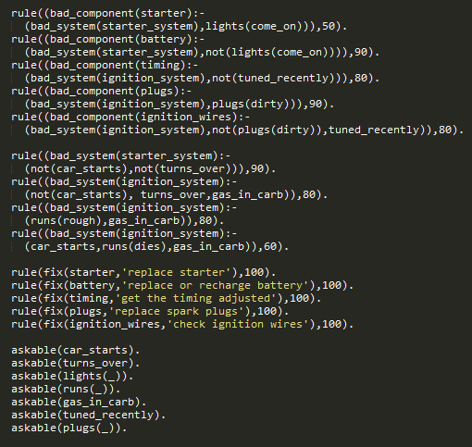

Figure 1. Knowledge Base

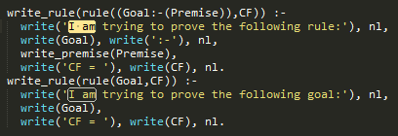

Figure 2. Explanation Subsystem

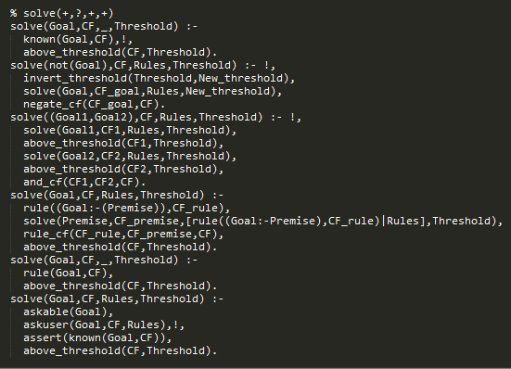

Figure 3. Inference Engine

The knowledge representation scheme was based off first-order logic and the knowledge representation is declarative. Here are some code excerpts below that describe the declarative and how it is related to first order logic:

This excerpt states that Tom is a cat, Jerry is mouse and a cat wants to eat a mouse. Notice that every fact and rule ends with a “.”

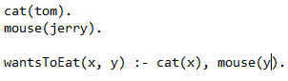

This excerpt was based of our MCO2. And it shows on how to declare a symptom or any other object you want. Notice that a symptom was followed by “:-“, this suggests that every object is defined by the rules that are the right of the “:-“

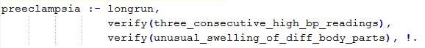

**The Knowledge Base**

For this section of the paper, rather than listing the rules our group has implemented into the system, the diseases and their corresponding symptoms will be the ones listed instead; so as to easily explain the logic behind the understanding and comprehension of how the inference engine derives its general diagnoses.

1. Preeclampsia:

IF patient

* Is more than 5 months pregnant
* Has three consecutive high blood pressure readings
* And has unusual swelling of different body parts

THEN the patient has preeclampsia

OR

* Is more than 5 months pregnant
* Has headache
* Has high blood pressure
* Experiencing nape pain
* Has swollen feet
* Is vomiting
* Experiencing loss of vision
* Has abdominal pain
* Has infection or immune system problems
* AND is obese

THEN the patient might have Preeclampsia

2. Hyperemesis:

IF patient

* Is less than 4 months pregnant
* Is weak
* Experiencing sleepiness often
* Is groggy sometimes
* Has a dry mouth
* Is not urinating
* Is vomiting excessively
* AND can’t walk or stand

THEN the patient has Hyperemesis

3. Miscarriage

IF patient

* Is less than 4 months pregnant
* Has blood in passage for 3 consecutive days
* AND has meaty material in passage

THEN the patient might have a Miscarriage

OR

* Is less than 4 months pregnant
* Is taking drugs OR drinks alcohol OR smokes
* Is lacking nutrition OR is a hard worker OR often lacks sleep
* Is anemic
* Has fast heart beat
* Has low blood pressure
* Experiencing loss of consciousness
* Experiencing abdominal pain
* AND is obese

THEN the patient might have a Miscarriage

4. Pneumonia

IF patient

* Is anemic OR is lacking in hydration OR lives in a someplace dry
* Has fever
* Has cough
* Is weak
* Experiencing breathing difficulties
* Has chest pain
* Is spitting blood
* AND has infection or immune system problems

THEN the patient has pneumonia

5. Gastroenteritis

IF patient

* Is experiencing excessive diarrhea

THEN the patient has Gastroenteritis

Or

* Is anemic OR is lacking hydration OR lives in someplace dry
* Has loss of appetite
* Is often vomiting
* Is experiencing a normal cycle of diarrhea
* Is feeling overall body weakness
* Has low blood pressure
* Has bloody stool
* AND has infection or has immune system problems

THEN the patient might have gastroenteritis

6. Premature Labor

IF patient

* Is more than 4 months pregnant
* Is lacking nutrition OR is a hard worker OR is often lacking sleep
* Is anemic
* Experiencing abdominal pain
* Experiencing bleeding of the vagina
* AND passage of vaginal fluids

THEN patient might have a premature labor

7. Bacterial Vaginosis

IF patient

* Discharges grey or whitish material
* AND feels a burning sensation when urinating

THEN the patient has bacterial vaginosis

8. Urinary Tract Infection

IF patient

* Feels a burning sensation while urinating
* Urinates frequently

THEN the patient has UTI

OR

* Has stomach or side pain
* AND has a fever

THEN the patient might have UTI

9. Placental Abruption

IF patient

* Has rapid and fine uterine contractions
* AND has uterine tenderness

THEN the patient has Placental Abruption

OR

* Experiences vaginal bleeding
* AND has abdominal pain

THEN the patient might have Placental Abruption

Notice how “has” and “might have” have been used in different cases. This is because the statements or clauses within the “has” diagnoses are the definitive symptoms of the diagnosed disease; while the “might have” statements on the other hand may occur, as a symptom, on other diseases as well. Other rules/clauses that make up some of the symptoms listed above, such as anemic or feverish, will no longer be discussed as they are already self-explanatory and understood as is.

**Contribution of Members**

We hereby certify that the detailed contributions, contribution percentages, and time recording logs presented below are correct representations of the individual effort and contribution of each member.

________________________

Aquino, Kurt Neil

________________________

Esquillo, Lance Patrick

________________________

Tapales, Carlo Gabriel

Aquino, Kurt Neil – 33.3%

* Additional research for the confirmation of acquired knowledge/data
* Knowledge representation
* Encoding of rules/diagnoses
* Implemented outcomes of the list of diseases into the program
* Implemented other clauses as general rules in the program
* Program testing/debuggging
* Evaluation and Analysis section of the paper
* Knowledge Base (AOG) section of the paper
* The Expert System Shell section of the paper

Esquillo, Lance Patrick – 33.3%

* General research for PROLOG
* Initial implementation of the program
* Knowledge representation
* Encoding of rules/diagnoses
* Implemented possible treatments of the list of diseases into the program
* Overall program testing/debugging
* The Expert System Shell section of the paper
* Knowledge Base (Appendix) section of the paper

Tapales, Carlo Gabriel – 33.3%

* Knowledge acquisition (Interview with the designated expert in subject field)
* General research for project topic
* Program testing/debugging
* Introduction section of the paper
* Sample Consultations section of the Paper
* Methodology section of the Paper
* Minutes section of the Paper
* Summary and Lessons Learned section of the paper

**References**

Cornforth, T. (2014). OB / GYN. Retrieved from <http://womenshealth.about.com/od/gynecologicalhealthissues/g/obgyn.htm>

Become an OBGYN: Education Requirements and Career Information. (n.d.). Retrieved from <http://education-portal.com/become_an_obgyn.html>

Lu, J., & Mead, J. (n.d.). PROLOG A Tutorial Introduction. Retrieved August 19, 2014, from <http://classes.soe.ucsc.edu/cmps112/Spring03/languages/prolog/PrologIntro.pdf>

Clocksin. (n.d.). Prolog Programming. Retrieved August 19, 2014, from <https://www.cl.cam.ac.uk/teaching/2001/PrologAI/PLVol1.ppt>